**Qualitative tests for carbohydrates**

**Molisch’s test**

It is a group test for all carbohydrates, whether free or in combined form. Despite its limitations, it is routinely used to detect the presence of carbohydrates.

**Principle**

The reaction is based on the fact that concentrated H2SO4 catalyses the dehydration of sugars to form furfural (from pentoses) or hydroxymethyl furfural (from hexoses).These furfurals then condense with sulfonated alpha-naphthol to give a purple or violet coloured product (furfuryl-diphenyl-methane-dyes). Polysaccharides and glycoproteins also give a positive reaction. In the event of the carbohydrate being a poly- or disaccharide, the acid first hydrolyses it into component monosaccharides, which then get dehydrated to form furfural or its derivatives.

**Reaction**

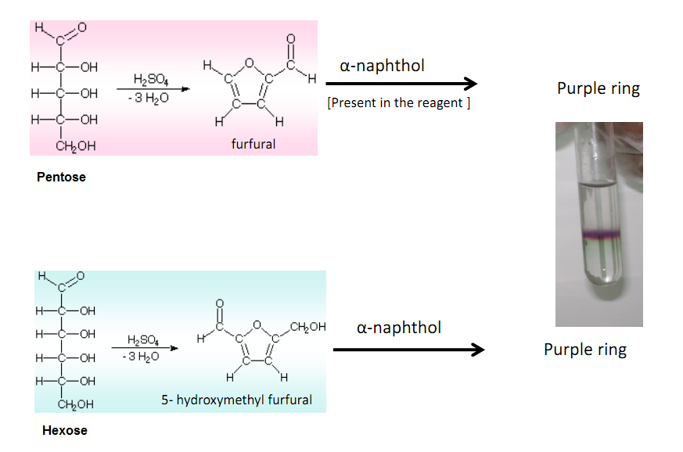

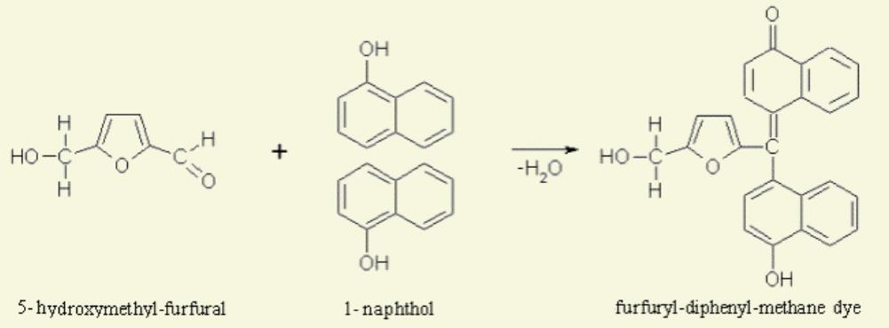

**Importance of molisch’s test**

Molisch test is very important because it is a general test for the presence of carbohydrates. It is used widely as compared to other tests because before every specific test for different carbohydrates a general test is important and that general test is performed via molisch test. Another important thing is that, this test is positive for all types of carbohydrates whether free or in combined form like glycoprotiens,glycolipids etc.

**Reagents**

1. i) Conc.H2SO4
2. ii) Molisch’s reagent: Alpha-naphthol 5%(w/v) in 95% ethanol

**Procedure**

* Take 1-2 mL of sample solution and add 2-3 drops of Molisch’s reagent (5% α-naphthol in 95% ethanol) and mix the contents.
* Incline the tube and carefully pour 1-2 mL of conc.H2SO4 down the side of tube so that the acid forms a layer beneath the aqueous solution.
* Observe the color at the interface between two layers and compare your result with a control test
* The formation of a purple or violet ring or zone at the junction of two layers indicates the presence of carbohydrates.

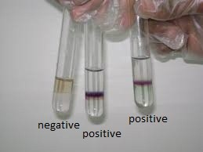

**Note**

* Apply this test two different carbohydrate solutions of your own choice, preferably to one monosaccharide and one polysaccharide.
* A brown color due to charring must be ignored and the test should be repeated with a more dilute sugar solution.

**Precautions**

1. Alpha-naphthol solution is unstable and should be prepared fresh.
2. The conc.H2SO4 should be added carefully along the sides of the test tube causing minimal disturbance to the contents of the tube.
3. Add only few drops of molisch’s reagent. We don’t need to add much.
4. Add acid with great care as we use strong acid in this test and it could burn our skin.
5. Don’t shake the test tube when ring is formed. If we do so, it would destroy the ring.

**Limitations**

In addition to carbohydrates, furfurals as such, some organic acids, aldehydes and ketones also give this test. Secondly, a concentrated sugar solution may give a red colour instead of purple owing to charring action of acid.

**TESTS FOR REDUCING SUGARS**

Reducing sugars are sugars that have the hemiacetal or hemiketal functional group somewhere in their molecular structure. Either of these two functional groups will be in equilibrium with a free aldehyde group which will be very easily oxidized to a carboxylic acid. This oxidation will be accompanied by the reduction of the oxidizing agent often copper(II) ion or silver(I) ion. The copper(II) ion is reduced to copper(I) ion and the silver ion to silver metal. This is [was] a major way of silvering glass to make mirrors including reflecting telescope mirrors. It is the oxidation number of the oxidizing agent that is reduced in value.

**Fehlings test for carbohydrates**

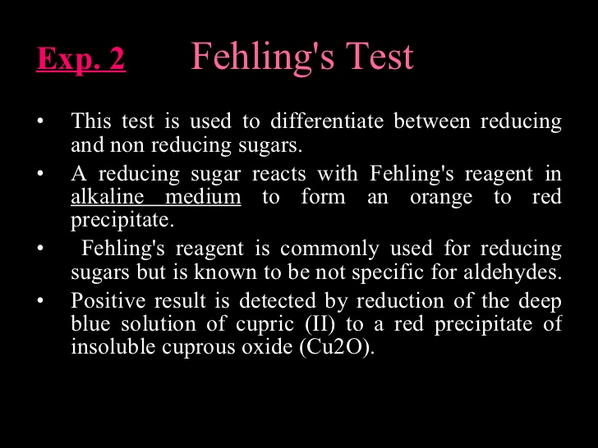

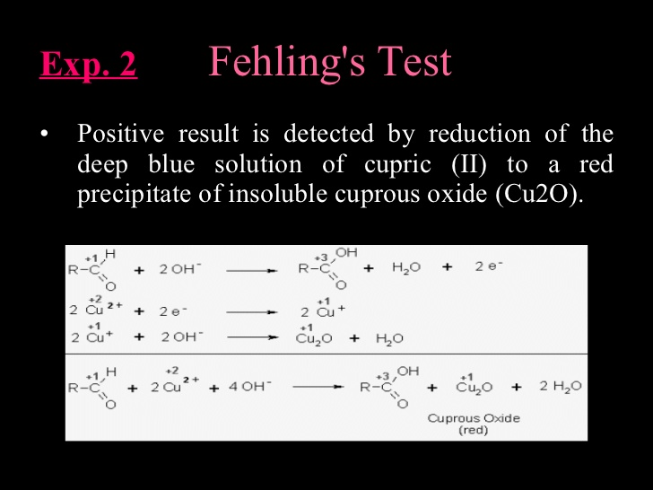

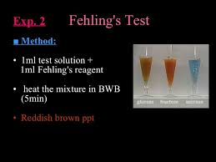

**Benedicts test**

**Benedict’s Test** is used to test for simple carbohydrates. The **Benedict’s test** identifies reducing sugars (monosaccharide’s and some disaccharides), which have free ketone or aldehyde functional groups. Benedict’s solution can be used to test for the presence of glucose in urine.

Some sugars such as glucose are called reducing sugars because they are capable of transferring hydrogens (electrons) to other compounds, a process called reduction. When reducing sugars are mixed with Benedicts reagent and heated, a reduction reaction causes the Benedicts reagent to change color. The color varies from green to dark red (brick) or rusty-brown, depending on the amount of and type of sugar.

**Benedict’s quantitative reagent** contains potassium thiocyanate and is used to determine how much reducing sugar is present. This solution forms a copper thiocyanate precipitate which is white and can be used in a titration. The titration should be repeated with 1% glucose solution instead of the sample for calibration

**Principle of Benedict’s Test**

When Benedict’s solution and simple carbohydrates are heated, the solution changes to orange red/ brick red. This reaction is caused by the reducing property of simple carbohydrates. The copper (II) ions in the Benedict’s solution are reduced to Copper (I) ions, which causes the color change.

The red copper(I) oxide formed is insoluble in water and is precipitated out of solution. This accounts for the precipitate formed. As the concentration of reducing sugar increases, the nearer the final colour is to brick-red and the greater the precipitate formed. Sometimes a brick red solid, copper oxide, precipitates out of the solution and collects at the bottom of the test tube.

**Sodium carbonate** provides the alkaline conditions which are required for the redox reaction. **Sodium citrate** complexes with the copper (II) ions so that they do not deteriorate to copper(I) ions during storage.

Complex carbohydrates such as starches DO NOT react positive with the Benedict’s test unless they are broken down through heating or digestion (try chewing crackers and then doing the test). Table sugar (disaccharide) is a non-reducing sugar and does also not react with the iodine or with the Benedict Reagent. Sugar needs to be decomposed into its components glucose and fructose then the glucose test would be positive but the starch test would still be negative.

**Composition and Preparation of Benedict’s Solution**

Benedict’s solution is a deep-blue alkaline solution used to test for the presence of the aldehyde functional group, – CHO.

*Anhydrous sodium carbonate = 100 gm  
Sodium citrate – 173 gm  
Copper(II) sulfate pentahydrate = 17.3 gm*

One litre of Benedict’s solution can be prepared from 100 g of anhydrous sodium carbonate, 173 g of sodium citrate and 17.3 g of copper(II) sulfate pentahydrate.

**Procedure of Benedict’s Test**

1. Approximately 1 ml of sample is placed into a clean test tube.
2. 2 ml (10 drops) of Benedict’s reagent (CuSO4) is placed in the test tube.
3. The solution is then heated in a boiling water bath for 3-5 minutes.
4. Observe for color change in the solution of test tubes or precipitate formation.

**Result Interpretation of Benedict’s Test**

If the color upon boiling is changed into green, then there would be 0.1 to 0.5 percent sugar in solution.  
If it changes color to yellow, then 0.5 to 1 percent sugar is present.  
If it changes to orange, then it means that 1 to 1.5 percent sugar is present.  
If color changes to red,then 1.5 to 2.0 percent sugar is present.  
And if color changes to brick red,it means that more than 2 percent sugar is present in solution.

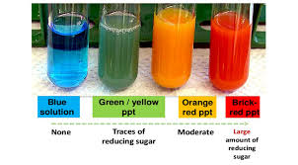

**Positive Benedict’s Test:** Formation of a reddish precipitate within three minutes. Reducing sugars present. Example: Glucose  
**Negative Benedict’s Test:** No color change (Remains Blue). Reducing sugars absent. Example: Sucrose.

**Barfoed’s carbohydrate test**

Barfoed's test is used to detect the presence of monosaccharide (reducing) sugars in solution. Barfoed's reagent, a mixture of ethanoic (acetic) acid and copper (II) acetate, is combined with the test solution and boiled. A red copper (II) oxide precipitate is formed will indicates the presence of reducing sugar. The reaction will be negative in the presence of disaccharide sugars because they are weaker reducing agents. This test is specific for monosaccharides . Due to the weakly acidic nature of Barfoed's reagent, it is reduced only by monosaccharides in a fast manner. Barfoed's reagent reacts with monosaccharides to produce cuprous oxide at a faster rate than disaccharides. A copious amount of brick-red precipitate indicates a reducing monosaccharide. Some hydrolysis of disaccharides may lead to trace precipitates (disaccharides generally don't give any reaction even for ten minutes). The precipitate isn't nearly as voluminous as that seen with Benedict's test and tends to adhere to the walls of the test tube.

RCHO + 2Cu2+ + 2H2O -----> RCOOH + Cu2O + 4H+

**Seliwanoff’s Test:**

It is a color reaction specific for ketoses. When concentrated HCl is added, ketoses undergo dehydration to yield furfural derivatives more rapidly than aldoses.  These derivatives form complexes with resorcinol to yield deep red color. The test reagent causes the dehydration of ketohexoses to form 5-hydroxymethylfurfural. 5-hydroxymethylfurfural reacts with resorcinol present in the test reagent to produce a red product within two minutes. Aldohexoses reacts so more slowly to form the same product.

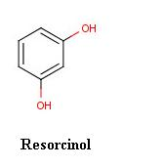

 Sucrose may give a positive ketohexose test because of partial hydrolysis to glucose and fructose. Other sugars give a red colour upon prolonged heating. Some sources say an apricot colour is negative. This depends on the concentration in the sample, and sugars like glucose give essentially no colour even after ten minutes.

**Bial’s Test:**

 Bial’s test is used to distinguish between pentoses and hexoses. Pentose is one of the most important chemical substance. Before a German Physician did a test to check its presence, there were no methods to do it. You couldn’t easily tell whether Pentose is present in a compound or not. But when Manfred Bial performed this test to check the presence of Pentose, it brought a revolution. Today you can easily check the presence of Pentose in any compound with the help of Bial’s test. The reagents involved include orcinol 0.4g, 200 ml of hydrochloric acid and 0.5 ml of ferric chloride solution. Pentoses react with Bial’s reagent and are converted to furfural. Orcinol and furfural condense in the presence of ferric ion to form a colored product. Appearance of green colour or precipitate indicates the presence of pentoses and formation of muddy brown precipitate shows the presence of hexoses. The procedure is simple and includes

* In the first step, the sample solution of amount 2 ml is placed in a test tube.
* In this solution, the next step is to add Bial’s reagent in the amount of 2 ml.
* The 3rd step in the test is to heat the solution. That could either be done in the Bunsen burner or a hot water bath.
* Any changes in color are observed. Green precipitate indicates the presence of pentoses

**Iodine Test:**

This test is used for the detection of starch in the solution. The blue-black colour is due to the formation of starch-iodine complex. Starch contain polymer of α-amylose and amylopectin which forms a complex with iodine to give the blue black colour. Other polysaccharides such as glycogen and cellulose do not show this blue black color in the presence of iodine. Iodines solution can also be referred to as Lugol’s solution it contains iodine and potsssium iodode (KI). The use of Lugol's iodine reagent (IKI) is useful to distinguish starch and glycogen from other polysaccharides. Lugol's iodine yields a blue-black color in the presence of starch. Glycogen reacts with Lugol's reagent to give a brown-blue color. Other polysaccharides and monosaccharides yield no color change; the test solution remains the characteristic brown-yellow of the reagent. It is thought that starch and glycogen form helical coils. Iodine atoms can then fit into the helices to form a starch-iodine or glycogen-iodine complex. Starch in the form of amylose and amylopectin has less branches than glycogen. This means that the helices of starch are longer than glycogen, therefore binding more iodine atoms. The result is that the color produced by a starch-iodine complex is more intense than that obtained with a glycogen-iodine complex.

Iodine Test (Starch/Amylose) A few drops of 0.01 M iodine in 0.12 M KI are added to a 1% solution of the carbohydrate in question. The immediate formation of a vivid blue color indicates amylose. With starch a blue black coloration forms due to the polyiodide complex formed.

**Osazone Test:**

The ketoses and aldoses react with phenylhydrazine to produce a phenylhydrazone which further reacts with another two molecules of phenylhydrazine to yield osazone. Needle-shaped yellow osazone crystals are produced by glucose, fructose and mannose, whereas lactosazone produces mushroom shaped crystals.

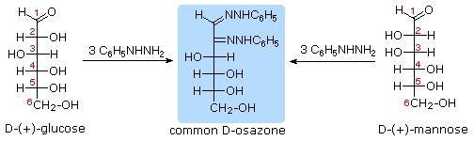

Three molecules of phenyhyrazine are required as shown above and the react with the first two carbons on the sugar. This test is rarely used for identification of sugars today.

Crystals of different shapes will be shown by different osazones. Flower-shaped crystals are produced by maltose.